

**Internet**

SARV Web Internal Network Architecture.

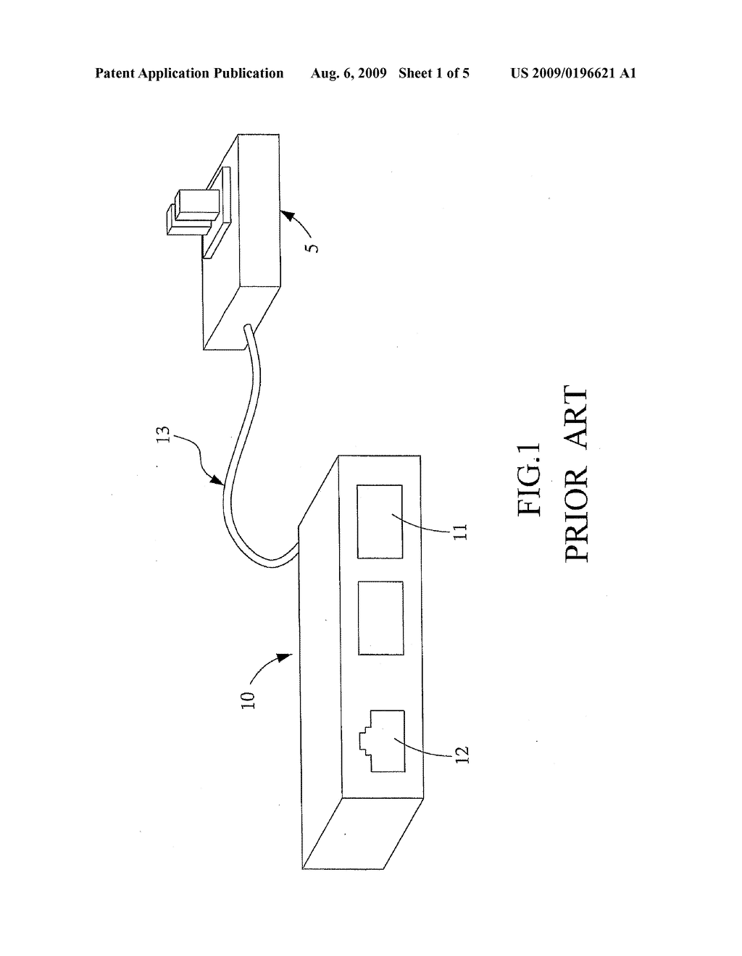

**Optical to LAN converter**

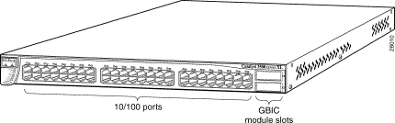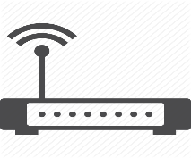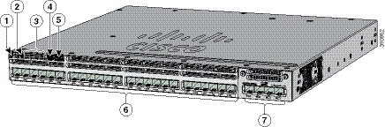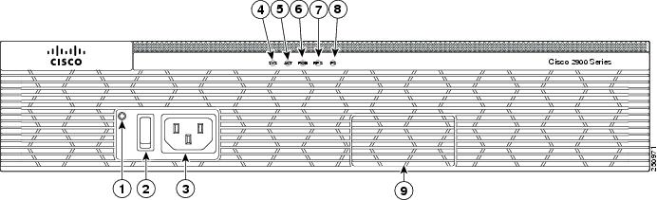

**Router IP = 103.255.100.1**

**Gateway = 103.255.100.2**

**L3 Switch IP = 103.255.100.3**

**Switch for Support Dept.**

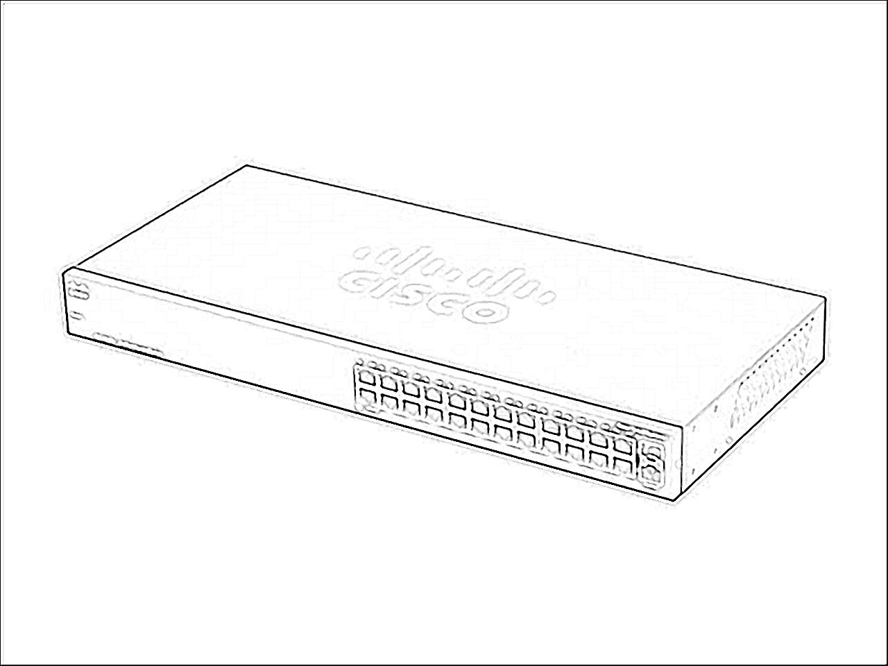

**CISCO Wi-fi Router**

**CISCO SG00 L3 Switch**

**Switch for Sales & accounts Dept.**

**CISCO 2900 Router**